**Verification of the Serpent-Griffin Workflow using the SNAP 8 Experimental Reactor**

**Isaac Naupa1, Sam Garcia2, Stefano Terlizzi3, Abdalla Abou-Jaoude3, Ben Lindley2,Dan Kotlyar1**

1Georgia Institute of Technology

770 State St NW, Atlanta, GA 30313

2University of Wisconsin Madison

1500 Engineering Dr, Madison, WI 53706

3Idaho National Laboratory

995 MK Simpson Blvd, Idaho Falls, ID 83401

[iaguirre6@gatech.edu](mailto:iaguirre6@gatech.edu), [sgarcia9@wisc.edu](mailto:sgarcia9@wisc.edu), [stefano.terlizzi@inl.gov](mailto:stefano.terlizzi@inl.gov), [Abdalla.AbouJaoude@inl.gov](mailto:Abdalla.AbouJaoude@inl.gov), [lindley2@wisc.edu](mailto:lindley2@wisc.edu), [dan.kotlyar@me.gatech.edu](mailto:dan.kotlyar@me.gatech.edu),

# ABSTRACT

The Systems for Nuclear Auxiliary Power (SNAP) program accumulated extensive experimental measurements over a span of 15 years. This work builds upon previous studies which validated Serpent against experimental data for various criticality configurations of the SNAP 8 Experimental Reactor (S8ER). A 2-stage sequence is applied here with Serpent used for the generation of few-group cross sections and Griffin as the transport eigenvalue solver. Sensitivity studies are performed to qualify the effect and uncertainty of various parameters, comparing against reference models for the S8ER. The results from this work will then be expanded to create a generalized methodology for the Serpent-Griffin 2-stage approach for microreactor applications.

# KEYWORDS: SNAP, SERPENT, GRIFFIN, MOOSE, MICROREACTOR, SPACE NUCLEAR, FSP

# INTRODUCTION

The S8ER was part of a fleet of reactors built during the Systems for Nuclear Auxiliary Power (SNAP) program [1]. These reactors were designed to be used in space as auxiliary power for components such as satellites. These systems were the first to explore novel microreactor technology and share many similar characteristics to modern designs that include comparable power output, compact core design, representative reactor-physics phenomena, alkali metal working fluids and high temperature solid moderators. They also share similar challenges, such as hydrogen migration.

This work is part of an ongoing joint effort between Georgia Tech, University of Wisconsin-Madison, BWXT, and INL that leverages extensive experimental data from the SNAP program to validate the performance of specific NEAMS tools in modeling effects that are unique to microreactor technology [2]. The activities reported here were sponsored by the National Reactor Innovation Center (NRIC) Virtual Test Bed (VTB) project (https://mooseframework.inl.gov/virtual_test_bed) .

# REACTOR DESCRIPTION

### System Characteristics

The S8ER was designed to operate for a total of 10,000 hours at a power level of 600 kWth. In the interest of reducing size, weight, and performance, the system used HEU in the form of Uranium-Zirconium Hydride (UZrH), with eutectic Sodium-Potassium Alloy (NaK) coolant in a tight hexagonal lattice arrangement. The main system characteristics are presented in Table I. The system uses a mix of burnable poisons as well as stationary and moveable reflectors for reactivity control. The core contains 211 elements arranged in a hexagonal lattice. Each element/rod contains the homogenous UZrH mix as the fuel base, a hydrogen diffusion barrier consisting of the ceramic AI-8763D infused with burnable poison Sm2O3, an internal atmosphere consisting of Helium as a gap, and a layer of Hastelloy N cladding. The fuel pins contain upper and lower endcaps for containment as well as indexing [1, 3].

**Table I.** System characteristics of the S8ER.

|  |  |
| --- | --- |
| **Parameter** | **Value** |
| Thermal power (kwth) | 600 |
| Inlet coolant temperature (k) | 1100 |
| Outlet coolant temperature (k) | 1300 |
| Heavy metal loading (kg U 93.15 weight %) | 6.56 |
| Fuel material | UZrH |
| Coolant material | NaK |
| Core vessel outer diameter (m) | 0.2372 |
| Number of fuel elements | 211 |
| Element pitch (m) | 0.01448 |
| Element outer radius (m) | 0.01352 |
| Element height (m) | 0.3556 |

# MODELING

As previously mentioned, the end objective is to assess the capabilities of different MOOSE-based computational tools and applications to model the reactor. The S8ER experiment serves as an ideal candidate to test MOOSE-based tools, such as Griffin, due to its small size and high neutron leakage. The latter together with the material heterogeneity introduces computational challenges associated to the generation of few-group parameters – a topic partially addressed in this paper.

Additional goal of this research is to minimize the reliance of resources external to MOOSE (e.g., Cubit [4] for mesh generation), and to simplify the workflow from cross-section generation to full Griffin model. For this reason, the mesh is fully generated inside MOOSE using a variety of Mesh Generator Objects. Furthermore, the Discontinuous Finite Element Discrete Ordinate (DFEM-SN) Transport Scheme, rather than the Continuous Finite Element Diffusion (CFEM-Diffusion) Scheme is used in the neutronic model. This allows to have a more direct workflow from generation of the few-group parameters to establishing our Griffin model. This approach allows to avoid the need to generate super homogenization (SPH) correction factors, to reach good agreement between Griffin and reference solutions when using CFEM-Diffusion. DFEM-SN is also heavily optimized for parallel computation and thus very suited for relatively large problems such as the one reported in the current study [5].

### Generation of Few-Group Parameters

For generation of the reference solution and neutronic data the Monte Carlo code Serpent was used [6]. It must be noted that this model is quite sensitive to the few-group energy structure and spatial resolution used in the generation of the few-group parameters [7]. Various sensitivity studies were conducted to find the ideal parameters that ensured good agreement between Griffin and Serpent.

**

**Figure 1. Serpent Model Radial and Axial Diagram.**

# PRELIMINARY RESULTS

The DFEM-SN solver in conjunction with the asynchronous parallel sweeper implemented in Griffin for the inversion of the streaming operator allows to efficiently perform neutron transport calculations in a parallel fashion on an unstructured mesh [5]. Additionally, it allows to streamline the modeling and simulation pipeline by avoiding the need for the generation of equivalence parameters. Preliminary results indicate agreement within 300 pcm between the Serpent reference and Griffin effective multiplication factor. However, there are still various optimization and sensitivity studies that could lead to additional improvement in code-to-code agreement. The system effective multiplication factor is the primary measure that will be used to quantify the fidelity of agreement between Serpent and Griffin. Uncertainties in the material composition, small geometry, and overall neutronics characteristics have been shown to make this a challenging validation exercise [7].

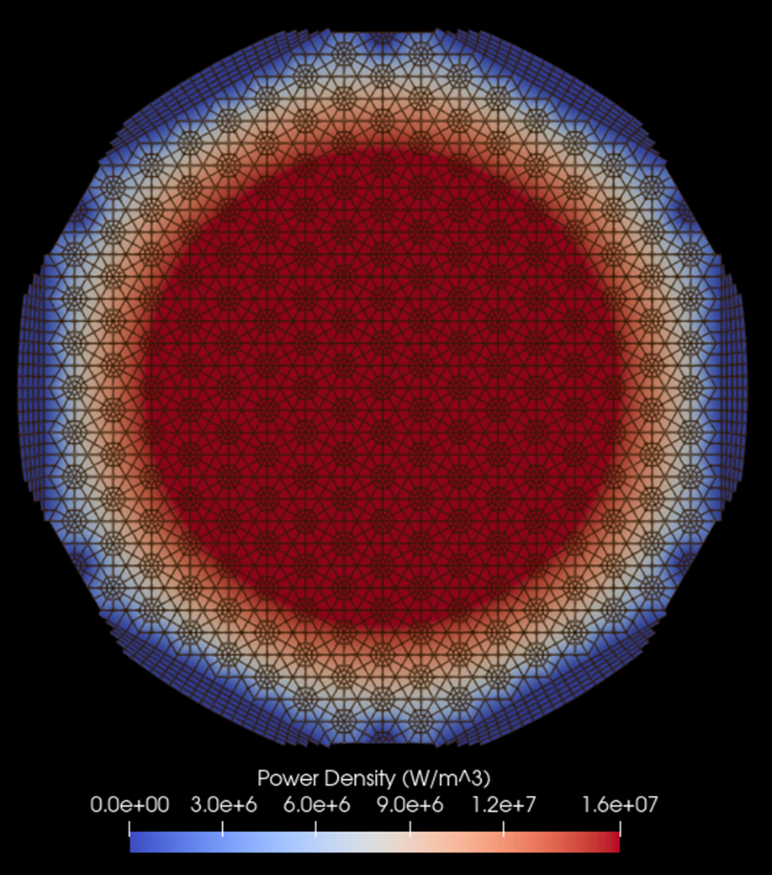

**Figure 1. Griffin Radial Power Distribution.**

# CONCLUSION & FUTURE WORK

Current work has developed a preliminary 2D model for the S8ER using the 2-stage Serpent-Griffin approach with preliminary results showing reasonable agreement with reference models at this stage.

The full conference paper will focus on developing and expanding upon the following:

* Sensitivity studies on the generation of the few-group parameters, specifically focusing on spatial resolution and energy group structure and overall effect of homogenization
* Sensitivity studies on the fidelity of unstructured mesh used in finite element analysis, effect of angular quadrature scheme and resolution, and effect of void regions and high anisotropy with respect to scattering moments

This paper is an initial assessment, which will then be followed by 3D modeling to be compared against the S8ER criticality experiments for various configurations with varying fuel element pattern loading, control drum orientation, and control element worth. These models will then be used to validate the 2-stage Serpent-Griffin model and develop a generalized methodology for microreactor applications.

# ACKNOWLEDGMENTS

The bulk of this work was performed at Idaho national Laboratory (INL) operated by Battelle Energy Alliance LLC under contract no. DE-AC07-05ID14517 with the U.S. Department of Energy (DOE). This work was prepared for the U.S. DOE through the National Reactor Innovation Center (NRIC). It also made use of the resources of the High Performance Computing Center at Idaho National Laboratory, which is supported by the Office of Nuclear Energy of the U.S. Department of Energy and the Nuclear Science User Facilities under contract no. DE-AC07-05ID14517. The U.S. Government retains for itself, and others acting on its behalf, a paid-up nonexclusive, irrevocable worldwide license in said article to reproduce, prepare derivative works, distribute copies to the public, and perform publicly and display publicly, by or on behalf of the Government. The DOE will provide public access to these results of federally sponsored research in accordance with the DOE Public Access Plan: energy.gov/downloads/doe-public-access-plan.

This work was also supported by funding received from the DOE Office of Nuclear Energy’s Nuclear Energy University Program under contract number DE-NE0009217.

# REFERENCES

1. Atomics International Division. “SNAP 8 summary report,” Technical Report, Atomics International Division, 1973. URL: https://www.osti.gov/biblio /4393793, doi:10.2172/4393793.
2. S. Garcia, I. Naupa, D. Kotlyar, and B. Lindley. “Validation of SNAP8 Criticality Configuration Experiments using SERPENT,” *In Proceedings of ANS Winter Conference* (2022).
3. D.E. Crouter, “SNAP 8 Experimental Reactor Critical Experiment”. Canoga Park, CA: Atomics International, 1964, NAA-SR-9642.
4. Coreform Cubit (Version 202x.x) [Computer software]. Orem, UT: Coreform LLC. Retrieved from http://coreform.com
5. Y. Wang, Z. M. Prince. “Performance improvements for the griffin transport solvers,” 2021. URL: https://www.osti.gov/biblio /4260713, doi:10.2172/1822446.
6. J. Leppänen, et al. “The Serpent Monte Carlo code: Status, development and applications in 2013," *Ann. Nucl. Energy*, 82 (2015) 142-150 (2015).
7. L. D. Swenson. “Snap 8 development reactor nuclear analysis,”. URL:https://www.osti.gov/biblio/4709921, doi:10.2172/4709921 (1969).